# How to import XML reports from BDR-TEST envelopes to FDB

1. Open document page in BDR-TEST envelope

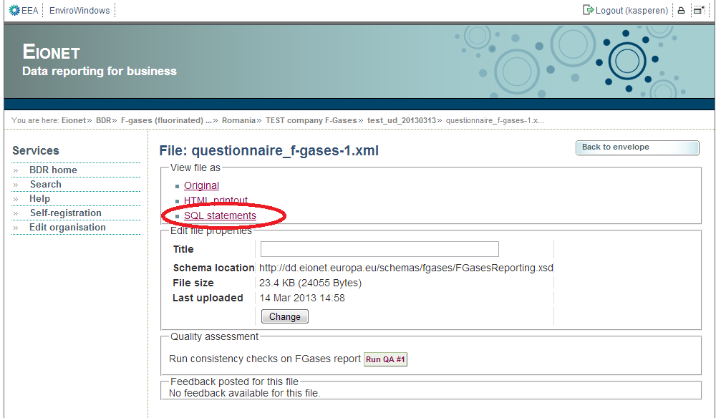

1. Save the SQL file in local computer (or alternatively select all SQL statemnt and click „Ctrl + c“)

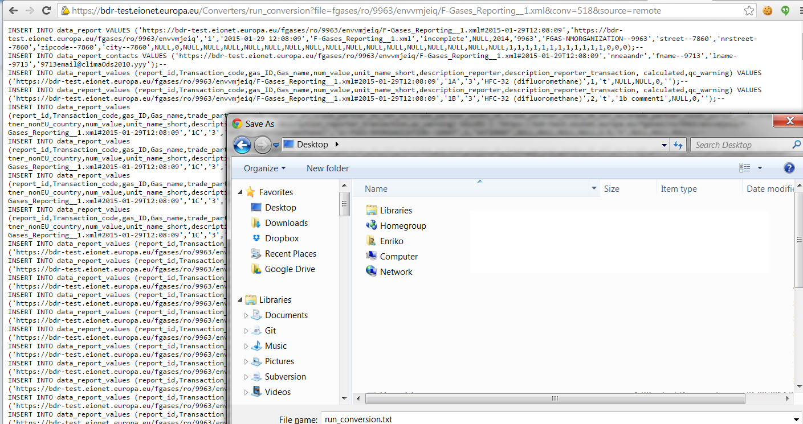

1. Select source database and click the button with „green +“ image

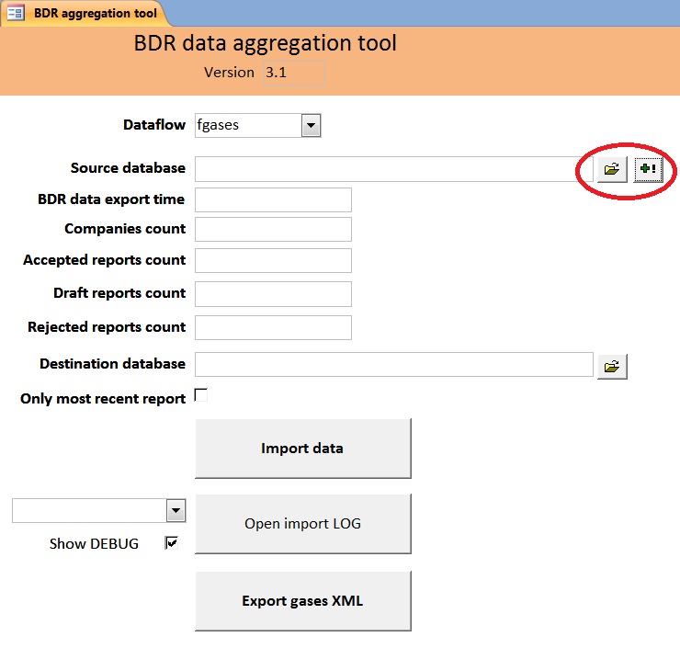

1. Select SQL file from local computer(see step 2) or alternatively paste the SQL statements to „Insert data“ form

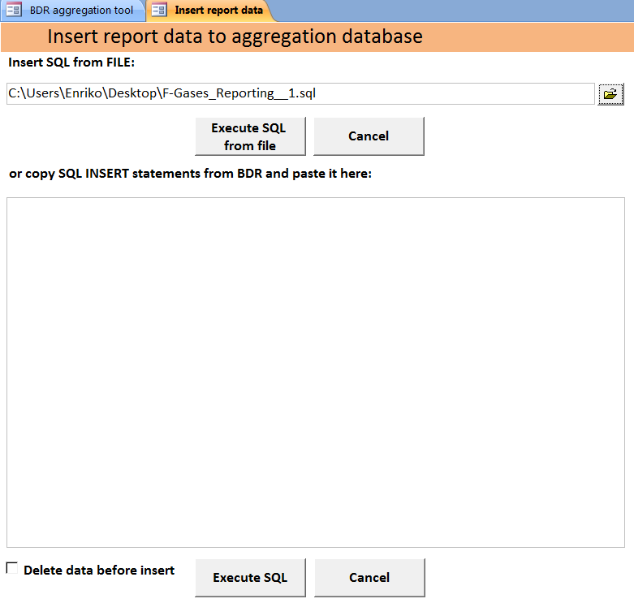

1. Check „Delete data before insert“ if you repeat the insert with the same report
2. Click "Execute SQL from file" or „Execute SQL“
3. Click „Import data“ on main form

